HIRING DEMO

S3 upload at 1.32 am

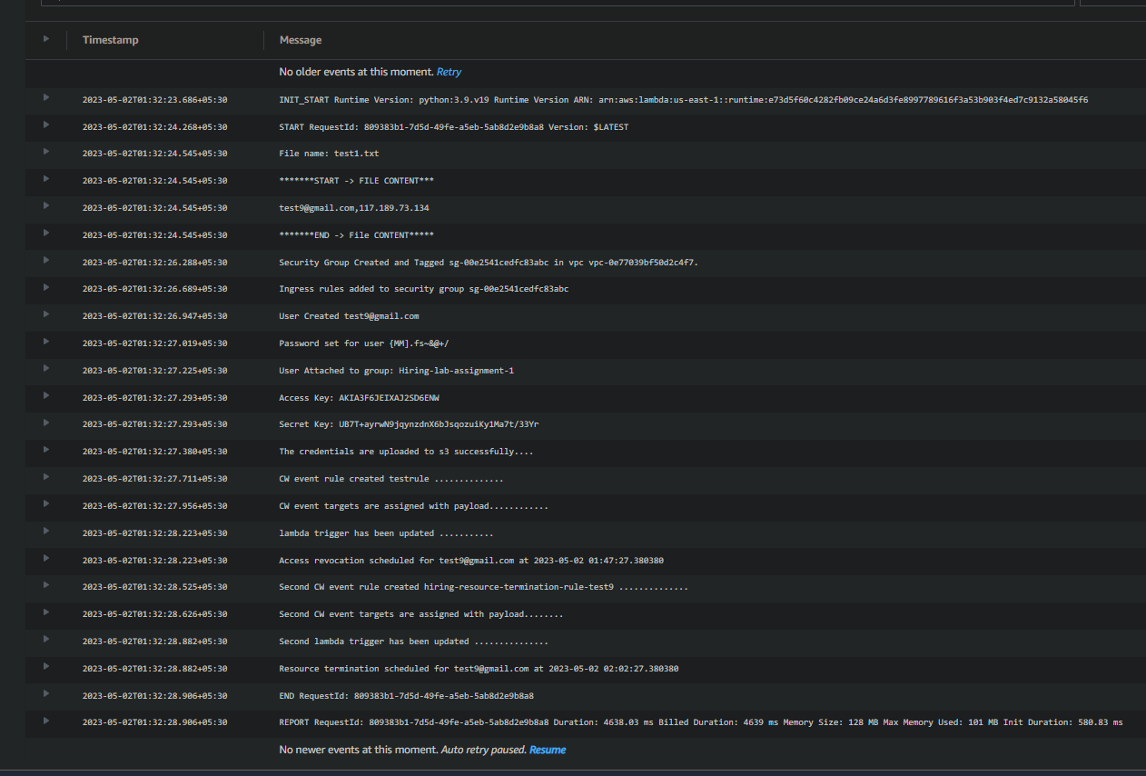

IAM revoke at 1.47

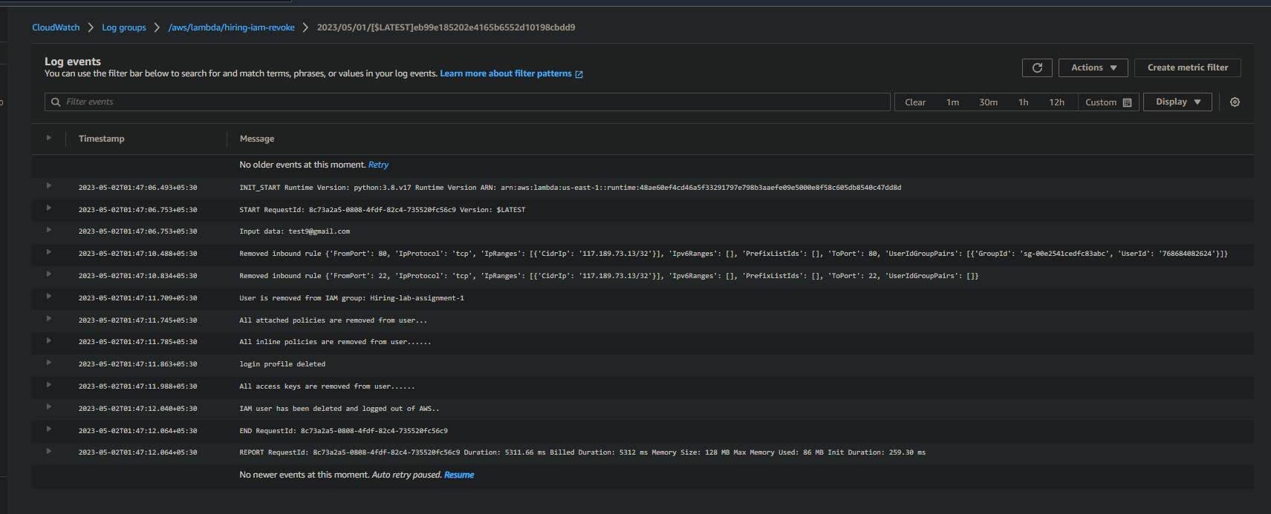

Resource terminataion at 2.02

